**Assignment no.3**

**Difference Between  
Multi-Threading and Multi-tasking**

In early days, computer was developed to solve problems. At that time, computer could only perform one task at a time. This lead to less CPU utilization where most of the time, CPU was idle. To make full use of the CPU, a concept of Operating system was istroduced. To make the waiting time, processing time less, some different approaches were defined that increased the usage of CPU to some extent. After that, multi-programming was introduced for good CPU utilization. Multi-programming OS runs multiple programs at once, nut in reality, it was not the case. If there were two processes at a time, one process was waiting to complete for I/O operations to complete the second job could use the idle CPU for execution. It increased the CPU utilization. It increased the CPU utilization. Multi-programming and multi-tasking term was used in the modern computer world.

People often get confused while comparing Multi-threading and Multi-tasking.

MULTI-TASKING is basically a logical extension to multi programming, that supports multiple programs to run concurrently. In multi-tasking more than one tasks are executed at the same time. In this technique the multiple tasks, also known as processes, share common processing resources such as a CPU. In the case of a computer with single CPU, only one job can be processed at a time. Multi-tasking solves the problem by scheduling and deciding which task should be the running task and when a waiting task should get turn. This system uses the CPU scheduling and multi-programming to provide each user with a small portion of a time-shared computer. Thus multi-tasking makes the best possible use of available hardware at any given instance of time and improves the overall efficiency of computer system. A multi-tasking operating system is characterized by its capability to support the concurrent execution of more than one task. A multitasking environment allows applications to be constructed as a set of independent tasks, each with a separate thread of execution and its own set of system resources.

For example a program is not capable of reading keystrokes while making drawings. These tasks cannot be executed by the program at the same time. This problem can be solved through multitasking so that two or more tasks can be executed simultaneously. Multitasking is of two types: Processor based and thread based. Processor based multitasking is totally managed by the OS, however multitasking through multi-threading can be controlled by the programmer to some extent.

While on the other hand Multi-threading is thread based multi-tasking. The concept of **multi-threading** needs proper understanding of these two terms – **a process and a thread**. A process is a program being executed. A process can be further divided into independent units known as threads. A thread is like a tiny light-weight process within a process. Or we can say a collection of threads is what is known as a process.

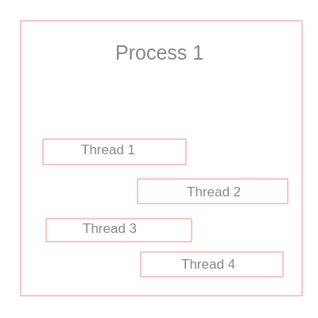

The above visual explains the concept of multi-threading

The basic difference between Multitasking and multi-threading is that **Multitasking** allows CPU to perform multiple tasks (program, process, task, threads) simultaneously whereas, **Multithreading** allows multiple threads of the same process to execute simultaneously. Now we will differentiate both of them.

|  |  |
| --- | --- |
| **Multithreading** | **Multitasking** |
| Multithreading let CPU to execute multiple threads of a process simultaneously. | Multitasking let CPU to execute multiple tasks at the same time. |
| In multithreading CPU switches between the threads frequently. | In multitasking CPU switches between programs frequently. |
| In multithreading system has to allocate memory to a process, multiple threads of that process shares the same memory and resources allocated to the process | In multitasking system has to allocate separate memory and resources to each program that CPU is executin |

## Key Differences Between Multitasking and Multithreading in OS

1. The basic difference between multitasking and multithreading is that in **multitasking**, the system allows executing multiple programs and tasks at the same time, whereas, in **multithreading**, the system executes multiple threads of the same or different processes at the same time.
2. In multitasking, CPU has to switch between multiple programs so that it appears that multiple programs are running simultaneously. On other hands, in multithreading cpu has to switch between **multiple threads** to make it appear that all threads are running simultaneously.
3. Multitasking allocates **separate memory and resources** for each process/program whereas, in multithreading threads belonging to the same process **shares the same memory and resources** as that of the process.

### Conclusion:

Multitasking is similar to multiprogramming whereas, Multithreading is thread-based multitasking.

Assignment by: Muhammad Ahmed Anis - IOT049117